12.30 PLANNING MEMORANDUM

The following describes the functionality and features included in Probe Audit Premium+

Objective

The objective of this document is to document the overall audit strategy and audit plan, record the entity information and planning meeting discussions, and obtain the engagement partner declaration.

The following key concepts of the Probe Audit Premium+ Methodology are set in this document:
- Development of the overall audit strategy setting scope, timing, and direction (ISA 300)
- Documentation of the auditor’s understanding of the entity, its environment, and the financial reporting framework
- Materiality assessment and risk-based planning decisions that drive all subsequent audit procedures

Document placement
Document 12.30 – Planning memorandum can be found in the Audit planning folder in the Caseware document manager.
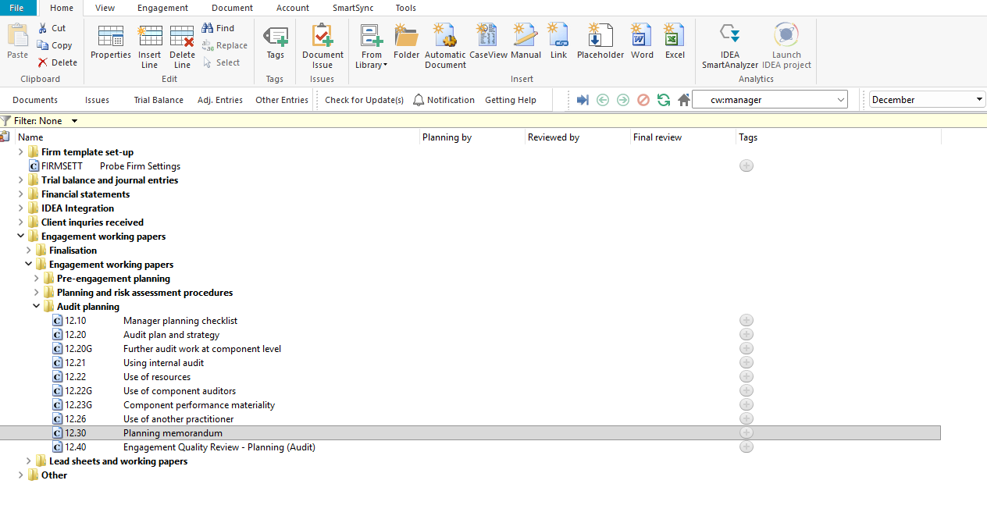

Document content
This document is designed to be a questionnaire and checklist type document with space for a comment or further description.
The document addresses the requirements of ISA 300 – Planning an Audit of Financial Statements and ISA 220 (Revised) – Quality Management for an Audit of Financial Statements. It covers the entity information, audit strategy, audit plan with assessed risk of material misstatement and audit strategy selections, planning meeting notes, other significant discussions, and the engagement partner declaration.
This document is divided into different bookmarks in the document map to assist you in documenting the planning memorandum:
- Entity information
- Audit strategy
- Audit plan
- Planning meeting notes
- Other significant discussions
- Engagement partner declaration
- Engagement partner
[Screenshot: Document map]

Layout
Column | Input Required | Outcome
Entity information
Consideration | No input is required in this column. Read the consideration and matters listed. | No impact on the engagement file.
Detail | Provide details of the entity information as required by the consideration. | No impact on the engagement file.
Risk | Record a risk or event by selecting the risk icon. | A risk or event will be recorded in the relevant risk table in the engagement file.
Ref. | Record a reference to supporting documentation. | No impact on the engagement file.
Audit strategy
Consideration | No input is required in this column. Read the consideration and matters listed. | No impact on the engagement file.
Detail | Provide details of the audit strategy as required by the consideration. | No impact on the engagement file.
Risk | Record a risk or event by selecting the risk icon. | A risk or event will be recorded in the relevant risk table in the engagement file.
Ref. | Record a reference to supporting documentation. | No impact on the engagement file.
Audit plan
SCOTABD | No input is required in this column. The significant classes of transactions, account balances and disclosures are auto-populated from the risk assessment in document 11.20. | No impact on the engagement file.
Assessed risk of material misstatement | No input required. The assessed risk levels per assertion (C, EO, RO, AVA, CO, PD) are auto-populated from document 11.20 – Inherent risk assessment. | No impact on the engagement file.
Audit strategy | Select the applicable audit strategy tick boxes for each SCOTABD. The columns include significant risk response, test of controls, required procedures, extended analytical procedures, extended tests of detail, and substantive sampling. | By selecting the audit strategy, the engagement file will be tailored and the relevant audit programs and procedures will be included in the engagement file.
Consideration | No input is required in this column. Read the consideration for additional audit plan matters. | No impact on the engagement file.
Detail | Provide details of the audit plan consideration. | No impact on the engagement file.
Risk | Record a risk or event by selecting the risk icon. | A risk or event will be recorded in the relevant risk table in the engagement file.
Ref. | Record a reference to supporting documentation. | No impact on the engagement file.
Planning meeting notes
Consideration | No input is required in this column. Read the consideration and matters listed. | No impact on the engagement file.
Detail | Provide details of the planning meeting discussions and outcomes. | No impact on the engagement file.
Risk | Record a risk or event by selecting the risk icon. | A risk or event will be recorded in the relevant risk table in the engagement file.
Ref. | Record a reference to supporting documentation. | No impact on the engagement file.
Other significant discussions
Consideration | No input is required in this column. Read the consideration and matters listed. | No impact on the engagement file.
Detail | Provide details of the significant discussions as required by the consideration. | No impact on the engagement file.
Risk | Record a risk or event by selecting the risk icon. | A risk or event will be recorded in the relevant risk table in the engagement file.
Ref. | Record a reference to supporting documentation. | No impact on the engagement file.
Engagement partner declaration
Question | No input is required in this column. Read the declaration question. | No impact on the engagement file.
Ref. | Cross-references are auto-populated where applicable. | No impact on the engagement file.
Detail | Provide details supporting the answer to the declaration question. | No impact on the engagement file.
Yes / No | Select Yes or No to the declaration question. | No impact on the engagement file.
Engagement partner
Engagement partner sign-off | Complete the engagement partner sign-off with a comment, name, signature and date. | No impact on the engagement file.

Document outcomes

The entity information section must be completed to document the nature of the business, history, specific business risks, significant events, related party relationships, key contacts, and applicable laws and regulations.

The audit strategy section must be completed to document the characteristics and scope of the engagement, reporting objectives, results of preliminary engagement activities, and resources necessary to perform the engagement.

The audit plan section must be reviewed to confirm the assessed risk of material misstatement for each SCOTABD and to select the appropriate audit strategy for each. Additional audit plan considerations relating to the use of CAATs, accounting work, risk assessment procedures, and supervision must be completed.

The planning meeting notes must be completed to document the engagement team discussion, including expected behaviour, problems, professional skepticism, susceptibility to material misstatement and fraud, materiality, and matters to be communicated to absent team members.

The other significant discussions section must be completed to document communication to the directors about the planned scope and timing of the audit and significant risks identified.

The engagement partner declaration must be completed by the engagement partner to confirm compliance with quality management, ethical requirements, independence, resources, competence, and review responsibilities.

The engagement partner sign-off must be completed with a comment, name, signature and date.

Group Audits

When the engagement type was selected as ‘Group Audit Single’ or ‘Group Audit Multiple’, questions are modified for the separate group audit engagement file.

Additional questions were added for group audit engagement to:
- Identify components for planning and performing of audit procedures;
- Determine expected involvement of component auditors in risk assessment procedures and further audit procedures;
- Evaluate access to components and component auditors; and
- Determine whether there is any indication that the group auditor will not be able to be sufficiently and appropriately involved in the work of the component auditor.

Some questions include red warnings or blue text in the description column. Follow the red warnings that inform you where key information should be recorded and the blue text in the description column that advises you where the understanding may be documented.

IN CONCLUSION

Features

The following features are available in the document:
- Insert or delete a comment, see page F3
- Insert or delete a row, see page F5
- Record a risk or event, see page F10
- Guidance, see page F16
- Freeze, see page F19

